Experiment-1.3

# Aim:

Write a program to implement Sales Revenue Prediction using Linear Regression.

# Software Required:

Any language compiler Python, Jupyter Notebook , Google Colab, Dataset.

# Description:

The experiment "Implementation of Sales Revenue Prediction using Linear Regression" focuses on developing a program that utilizes linear regression to predict sales revenue based on historical data. The experiment involves understanding the concept of linear regression, preparing the dataset, implementing the linear regression algorithm, evaluating the model's performance, and using it for sales revenue prediction.

# Pseudo code/Algorithms/Flowchart/Steps:

## Dataset Preparation:

Introduce the dataset containing historical sales revenue and independent variables. Load the dataset into the programming environment. Perform necessary data preprocessing steps, such as handling missing values, scaling, or encoding categorical variables.

## Exploratory Data Analysis:

Perform exploratory data analysis to gain insights into the dataset. Analyse the relationships between the

independent variables and the dependent variable (sales revenue) using visualizations, correlation analysis, or summary statistics.

## Programming Environment Setup:

Set up the programming environment with the chosen programming language. Import any necessary libraries or packages for data manipulation, visualization, and linear regression.

## Implementing Linear Regression:

Write a program to implement linear regression for sales revenue prediction. Divide the dataset into training and testing sets for model evaluation.Fit a linear regression model to the training data using the independent

variables and the corresponding sales revenue. Validate the model using the testing data and calculate relevant evaluation metrics such as mean squared error (MSE) or R-squared.

## Model Evaluation and Interpretation:

Evaluate the performance of the linear regression model based on the evaluation metrics obtained. Interpret the coefficients of the independent variables in the linear regression equation to understand their impact on sales revenue. Discuss any assumptions and limitations of the linear regression model.

## Sales Revenue Prediction:

Utilize the trained linear regression model to predict sales revenue for new or unseen data points. Input relevant independent variables (e.g., advertising expenditure, market size) into the model and obtain the predicted sales revenue.

## Experimentation and Analysis:

**Implementation and Output:**

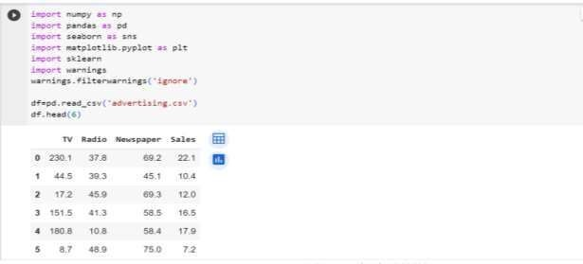

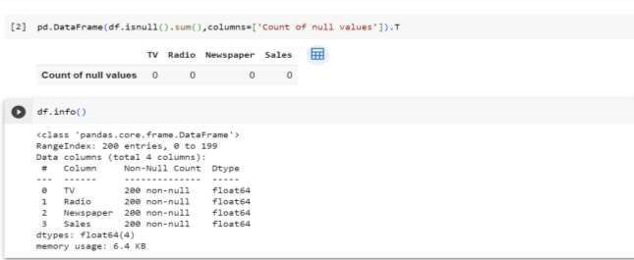

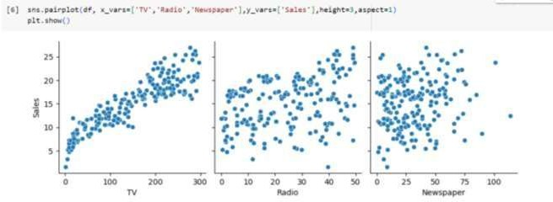

•

•

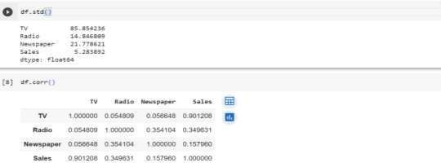

•

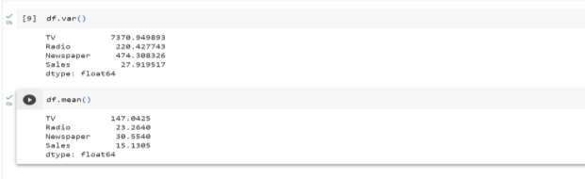

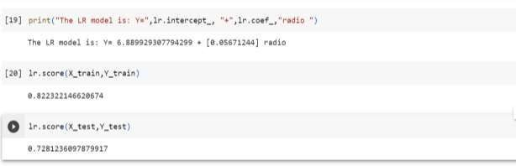

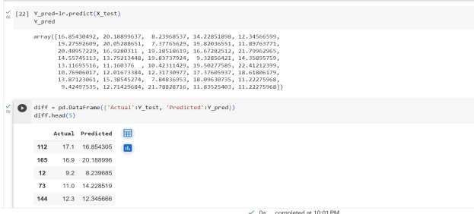

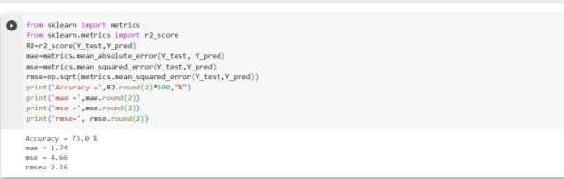

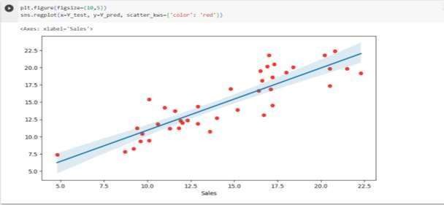

# Learning Outcomes:

1. Understand the concepts and principles of linear regression as a predictive modeling technique.
2. Gain proficiency in programming and implementing linear regression algorithms.
3. Apply data preprocessing techniques for preparing the dataset for regression analysis.
4. Perform feature selection and engineering to enhance the predictive power of the model.
5. Assess and interpret the performance of the linear regression model.